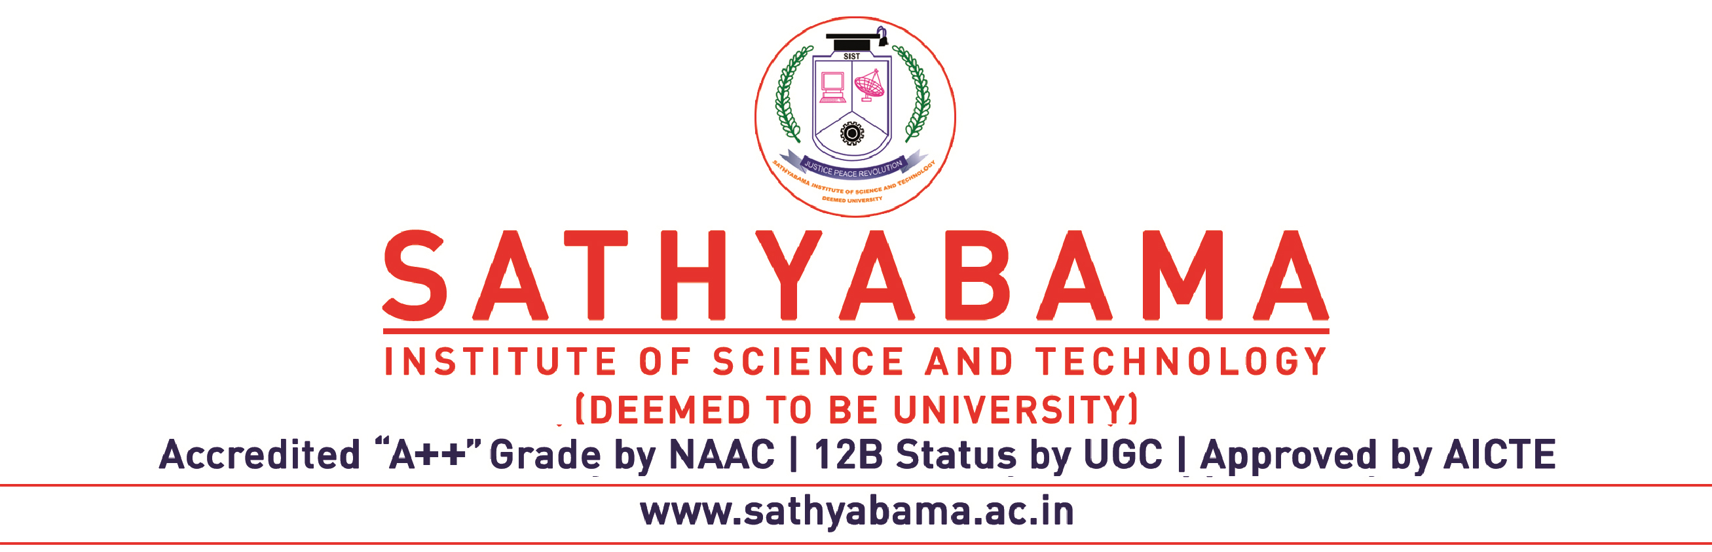

MINUTES OF THE EXTENSION MEETING
Date of Meeting : ______________Time: ____________
(As per UGC Guidelines on Examination, D.O.No.F.1-1/2020 (Secy), Dated 29th April, 2020) held at Sathyabama Institute of Science & Technology , through Video Conferencing Mode)
Fee Details (Enclose Copy)
Date | Amount | Receipt No.
Scholar Details:
- Name : Mr./Ms.___________________________________ Register Number : _________________
- Year of Admission______________ FACULTY : _______________________________________________
- Category : FULL TIME / PART TIME (Internal) / PART TIME (External)
- Official Address:_________________________ Residence Address:______________________________
________________________________ __________________________________
Mobile No: _______________________________ Email: _______________________________________
Supervisor Details:
- Name of the Supervisor :
- Name of the Joint Supervisor (if any) :
The following members were present

Sl. No. | Name of the Expert & MOBILE No. | OFFICE ADDRESS
1

2

PROPOSED RESEARCH TITLE: _______________________________________________________________ ___________________________________________________________________________________________
The committee has approved the area of research proposed and directed the candidate to go ahead with the literature review and suggested to register for the following courses.
A oral examination has been conducted and evaluated by the Doctoral Committee. The committee has given the following justification for extension of research work. After evaluating the performance and presentation thoroughly, the committee recommends to extension of registration of (Candidate Name) Mr./ Ms. __________________________ for Six months from ------------------------------------ to ----------------------------------------------

Justifications by Doctoral Committee :

Signature & Name
of the Member

Signature & Name
of the Supervisor

Signature & Name
of the Member

